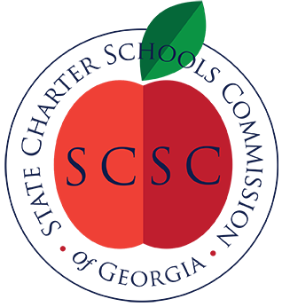
State Charter Schools Commission
Meeting Agenda

February 17, 2020 4:00 p.m.

Conference Call
1-888-808-6929; Access Code: 5206746

- Call to Order

- Establish Committee Meeting Schedule

- SCSC Funding Formula Review

- Public Comment

- Adjourn

