Please complete all sections of the Inventory Request Form and submit to darcy.callaway@scsc.georgia.gov via email. Requests will receive a response within 5 business days of receipt.

Inventory Request Form

School Name:

Today's Date:

Requested Retrieval Date:

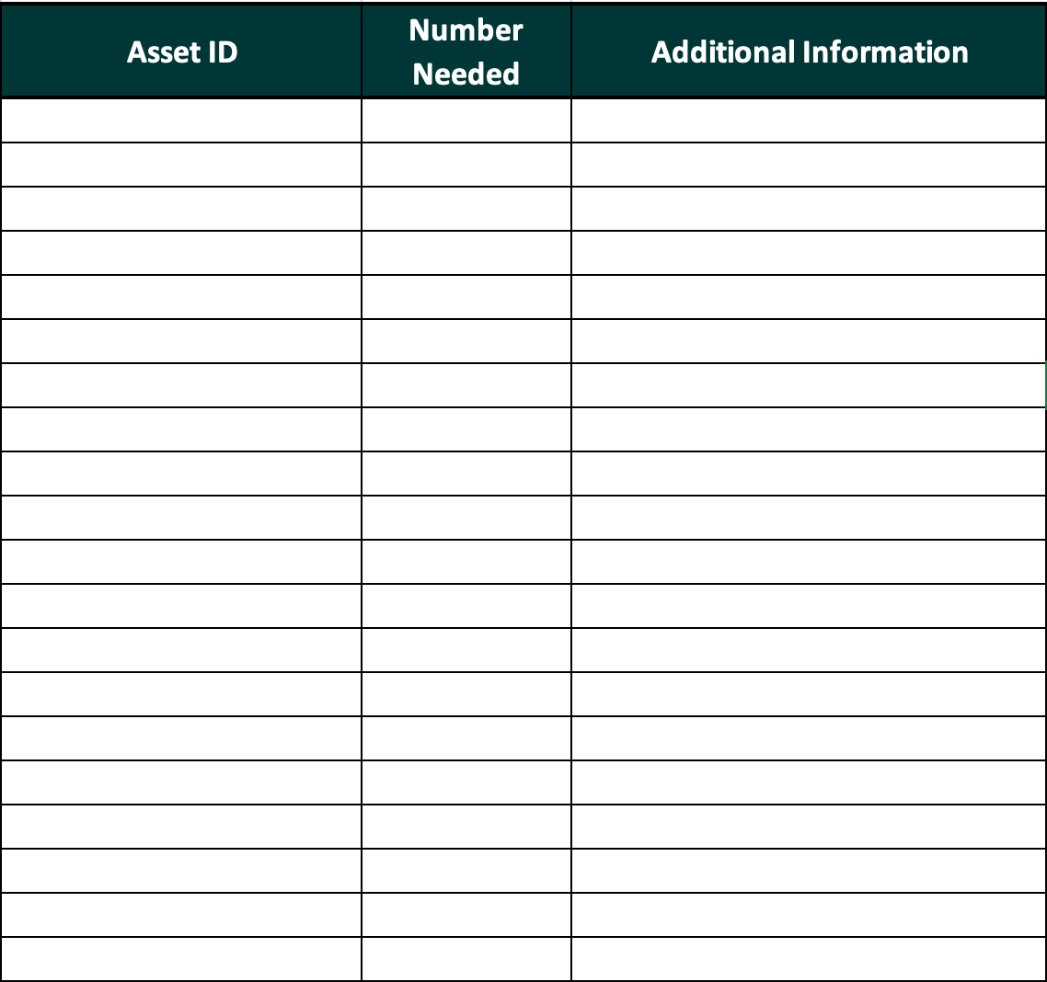

Approved/Denied By: Date:

